# **How safe is Air travel**

[](https://medium.com/@sathish.manthani?source=post_page-----e7d51ef132fe----------------------)

[Sathish Manthani](https://medium.com/@sathish.manthani?source=post_page-----e7d51ef132fe----------------------)

[Jul 11](https://medium.com/@sathish.manthani/how-safe-is-air-travel-e7d51ef132fe?source=post_page-----e7d51ef132fe----------------------) · 3 min read



A Nok Air Boeing 737–800 | Photo courtesy: [Thaiairways](https://www.thaiairways.com/en_AE/index.page)

## Recently media speculated that air travel is an unsafe mode of travel. So, we have decided to dig into the numbers and put the facts forward. Let’s check out how safe it is to board a flight.

There has been negative news on the safety of air travel in the media lately. It is natural for us to be fearful in response to highly publicized tragedies, but we need not rely solely on our emotions to protect ourselves. By analyzing the actual risks of air travel, you can understand how truly safe it is and board your next flight confidently.

So, rather than attempting to restore the faith in airline safety by comparing flying fatalities to other types of transportation, lets just first look at how air travel compares to the risk of death in our daily life activities. Later, we will also check how it compares to other transportation modes.

Some of the common causes of death and their fatalities for the year 2017 are shown below:

* [Unintentional fall deaths: 36,000](https://www.cdc.gov/nchs/fastats/accidental-injury.htm)
* [Unintentional poisoning deaths: 64,795](https://www.cdc.gov/nchs/fastats/accidental-injury.htm)
* [Suicides: 47,173](https://www.cdc.gov/nchs/fastats/suicide.htm)
* [Homicides: 19,510](https://www.cdc.gov/nchs/fastats/homicide.htm)

There were only [331 airline fatalities](https://www.bts.gov/content/us-general-aviationa-safety-data) in the year 2017. So as we can see, some of the common causes of deaths are significantly higher than air travel fatalities. So, we can say that air travel is not that riskier.

According to the [National Transportation Safety Board](https://www.ntsb.gov/investigations/data/pages/data_stats.aspx), there have been 32,000 to 38,000 motor vehicle fatalities every year in the United States since 2010. In other words, that is 1.13 fatalities per 100 million vehicle miles traveled. For the same period, there have been only [405 number of fatalities](https://www.bts.gov/content/us-general-aviationa-safety-data) (annual average) occurred in air travel.

Also, airline safety experts believe that the industry is likely to maintain and even improve these statistics as technology improves. Older airplanes are being replaced and even developing countries are striving to match the air safety standards of first-world countries. We can clearly see that improvement in the below chart.



**Fatal Accidents comparison: There is a significant drop (65%) in the number of fatal accidents in 2000–14 period.**

It is also found that the risk of an accident is much lesser in first-world airlines compared to the rest of the world. Airlines operated by developing countries are prone to more risk and it is shown below.

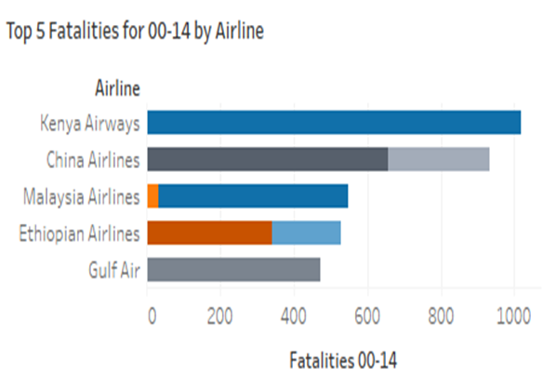

Top 5 airlines with most fatalities for 00–14. The chart also shows the fatalities in the prior period (1985–99) in a different color on the bar.

Kenya Airlines had the highest fatalities in 2000–14 but didn’t have any fatality in the prior period. If you notice, all these airlines are not operated by first-world countries.

It is important to note that the number of fatalities attributed to air travel has been declining rapidly over the past years. Considering that the number of flights and passenger miles has increased nearly as quickly, the actual rate of fatalities continues to fall dramatically by any measure. To simplify this information, there are now approximately three times as many passenger miles flown as there were 30 years ago, but fatalities are only half of what it used to be.

Finally, the airline industry is highly sophisticated, competitive, and dynamically evolving. Considering all the above aspects, air travel is arguably the safest means of traveling than other modes of transportation.

* [Blogposting](https://medium.com/tag/blogposting)